Friday, 4 July 2025

Machine learning notes

Cross validation

* Since there are many machine learning models, we might be confused which model to choose, here comes the cross valdation
* There are two steps involved
  + we need to estimate parameters for the model which is also known as training the data
  + Next we need to check how well the model performs
* Suppose we have a large block of data we can use 75% of data for training the model and the rest 25% of data to train the data. But we dont know which 75% of data to take.
* Cross validation takes each 75% data once and estimate the parameters and test the model on the rest 25%. and gives an average proformance of the model.

Confusion matrix

* A confusion matrix is a matrix that tells us what our algorithm did right and what it did wrong
* Example is a model that predicts whether a person has a heart disease or not. So a confusion matrix is such that the rows indicate the prdicted decision and colums represent true decison

|  | Person has heart disease | Person does not have hear disease |
| --- | --- | --- |
| Person has heart disease | 1 | FALSE POSITIVES |
| Person does not have heart disease | FALSE NEGATIVES | 1 |

Sensitivity and specificity

* After making the confusion matrix, we can find the sensitivity and specificity which are defined as follows
  + Sensitivity is defined as the percentage of true positives over true positivies and false negatives.
  + Specificity is defined as the percentage of true negatives over true negatives and fasle positives

Example

|  | Person has heart disease | Person does not have hear disease |
| --- | --- | --- |
| Person has heart disease | 139 | 20 |
| Person does not have heart disease | 32 | 112 |

Sensitivity calculation:

True positives = 139

false negatives = 32

therefore sensitivity = 139/(139 + 32) = 81.3%

Specificity calculation:

True negatives = 112

false positives = 20

therefore specificity = 112/(112 + 20) = 85%

Example for 3 x 3 confusion matrix

|  | Movie A | Movie B | Movie C |
| --- | --- | --- | --- |
| Movie A | 12 | 102 | 93 |
| Movie B | 112 | 23 | 77 |
| Movie C | 83 | 92 | 17 |

Sensitivity for movie A:

True positives = 12

False negatives = 112 + 83 = 195

sensitivity(movie A) = 12/(12 + 195) = 6%

specificity for movie A:  
True negatives = 23 + 77 + 92 + 17 = 209

False positives = 102 + 93 = 195

specificity (movie A) = 209/(209 + 195) = 51.73%

Bias and variance

* Variance is defined as how the model fits the datasets , example: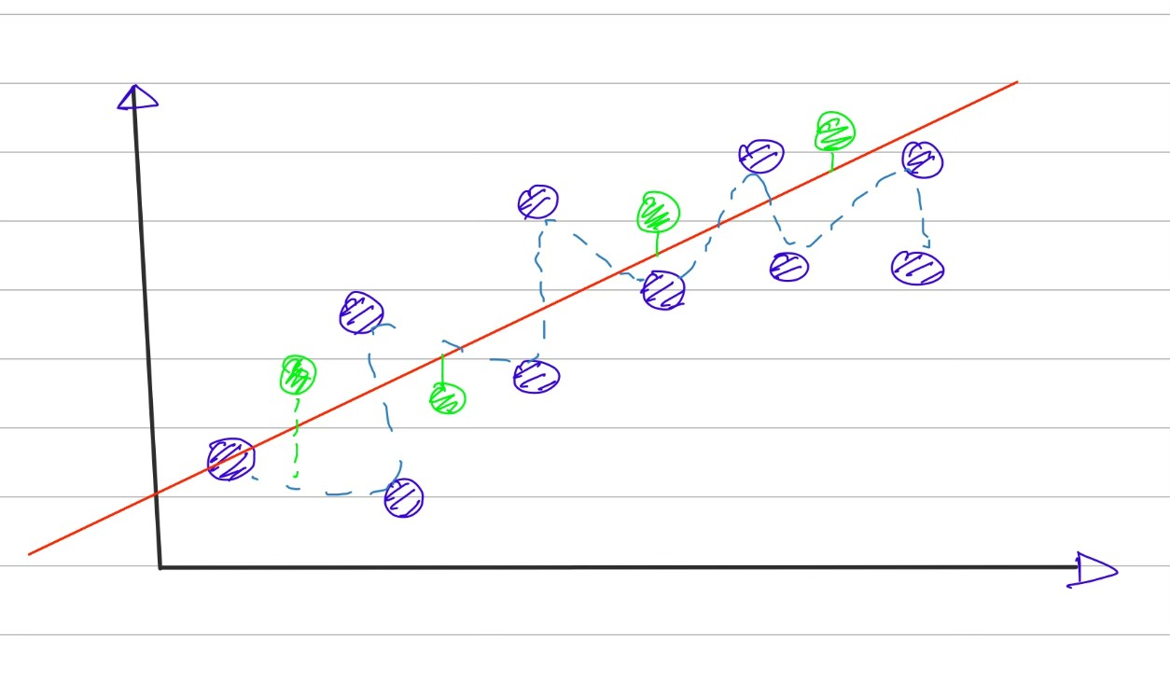

The squigly line has more variability than the straight line

* Bias: It is defined as how well the model fits the real world data. The squigly line has less bias than the straight line.

ROC AND AUC

* Suppose we want to classifiy subjects on basis of some of its characterstics like height, weight etc
* For eg, we want to classify mice as obese and non obese on the basis of their weights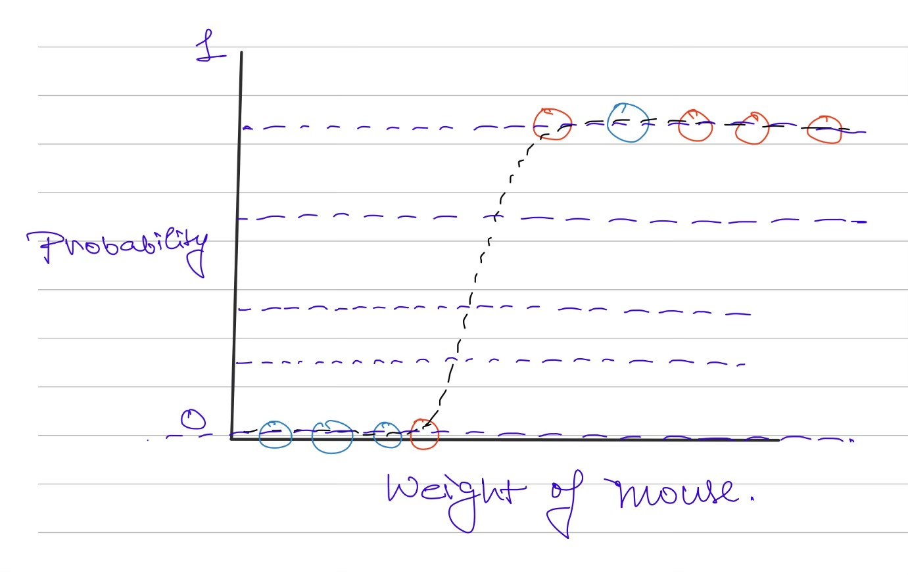

As you can see we need to set the threshold so that we can classify the mice

Each threshold value creates a confusion matrix .These large number of confusion matrices can be confusing so we plot a graph called ROC(reciever operator characterstic) which plots rate of false positives (1 - specificity) vs rate of true positives (sensitivity)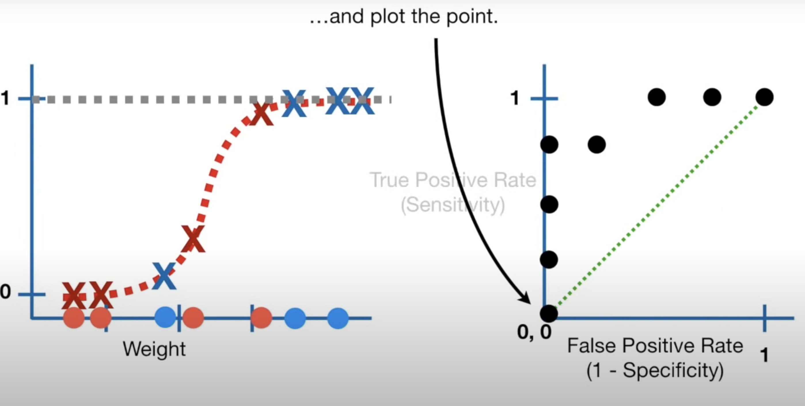

The area under the ROC gives AUC (area under the curve) . The larger the AUC the better the classification model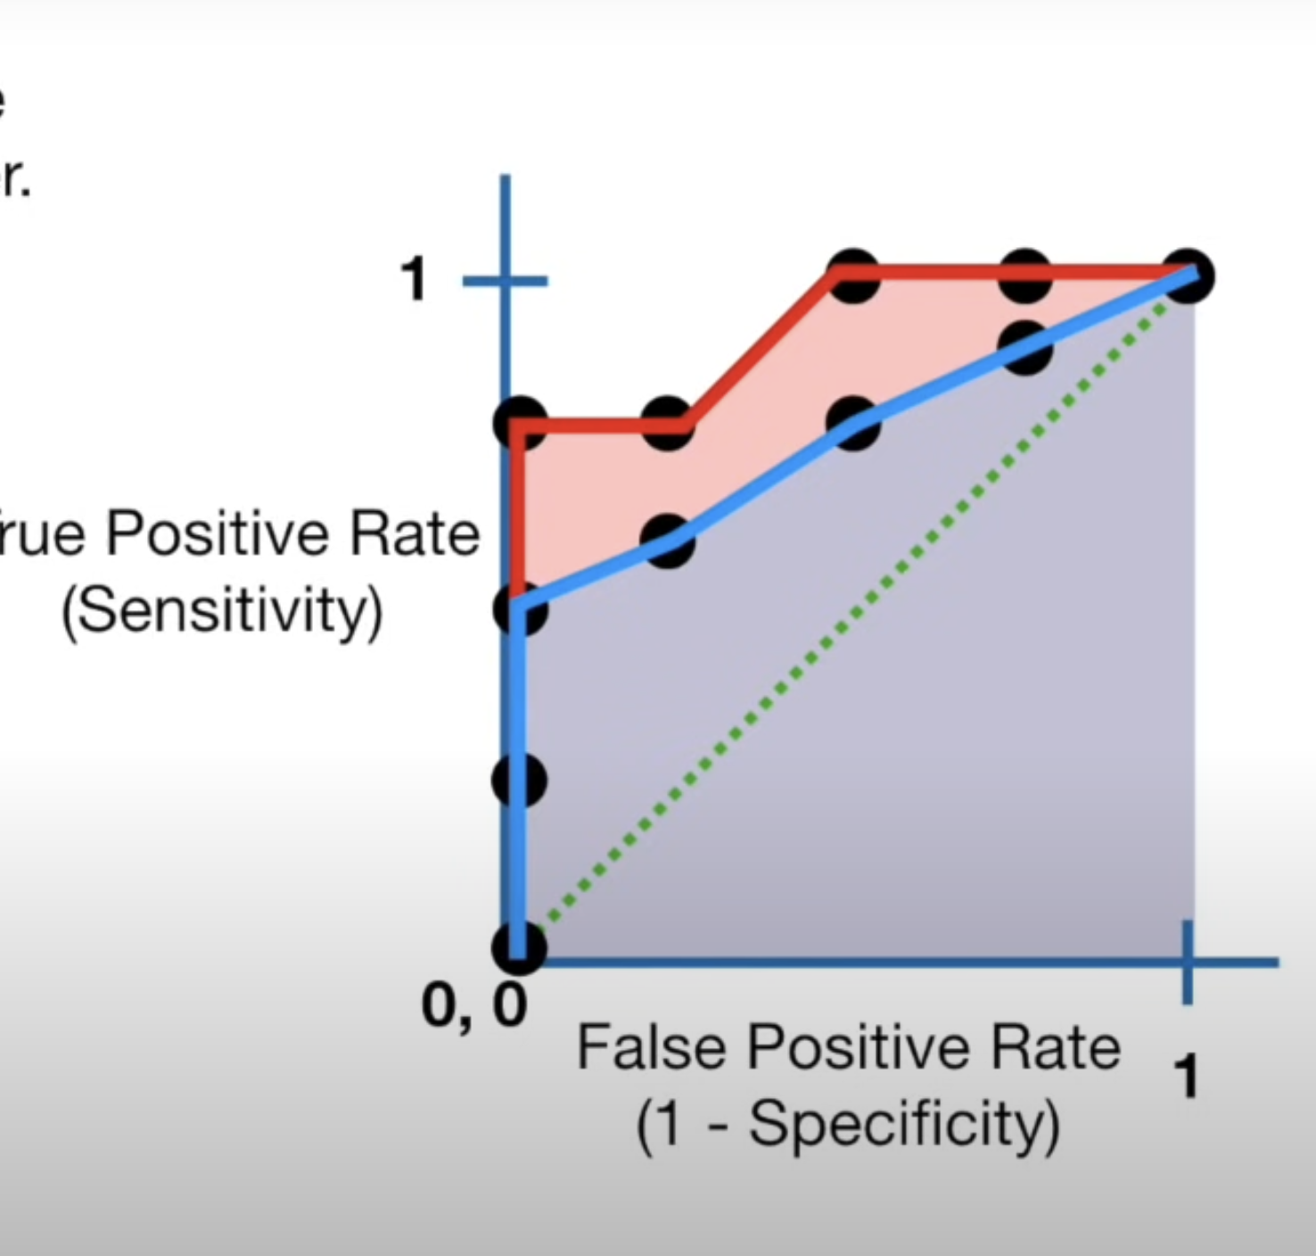

Red is AUC for logistic regression and blue is for random forest

Thus logisitic regression is better than random forest method

Entropy

* Before learning about entropy , we need to know about surprise
* Surprise can be seen as some sort of inverse of probability
* Instead of directly taking inverse of probability, we take logarithm of inverse of probability
$$surpise=log(\frac{1}{p(x)})$$

* We define entropy as expected value of surprise
$$E(Surprise)=∑(p(x).log\frac{1}{p(x)})$$

* suppose we have a coin with probability of head as 0.9 and probability of tails as 0.1, and we flip the coins 100 coins, we estimate the surprise of heads as (0.9x100)xs(head) and surprise of tails as (0.1x100)xs(tail). Therefore total surprise of 100 flips is estimated as (0.9x100)xs(head) + (0.1x100)xs(tail).
* Then we divide this estimated value by number of flips and thats how we get entropy. Thus we can write entropy as

Mutual Information

* Mutual information tells us about how closely two variables are .
* Mutual information for discrete variables is given by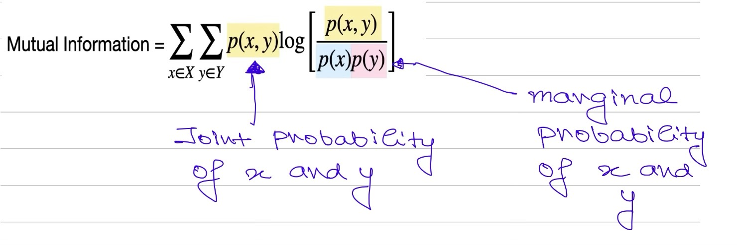
* Refer to the video below[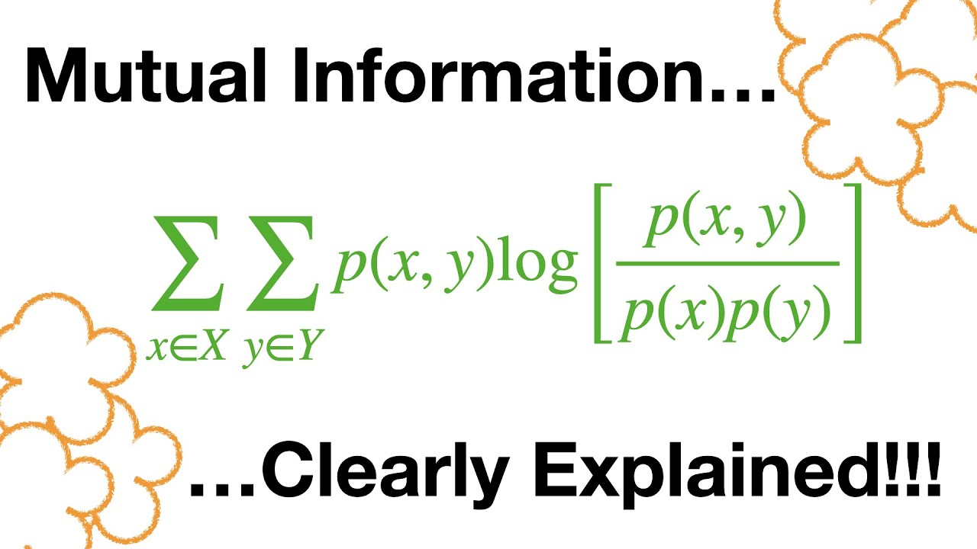](https://www.youtube.com/watch?v=eJIp_mgVLwE)
* For continuous variables , we can make a histogram and use the bins as the dicrete values
* The number of bins is equal to number of rows and columns for calculating mutual information

Fitting the best line

* While fitting a line to the observed data , the main concept is to minimize the square of distance of observed data from the data
* This can be done by plotting the sum of squares with respect to parameters and find the derivative where it is zero, the value of the parameters where the derivative of sum of squares with respect to parameters is zero is the best fitted line
* Here the parameters refer to the slope and intercept of the fitting line

Linear Regression

* Linear regression quantifies the relationship between two variables
* The parameter which quantifies how good the relationship is R-square value which is defined as var(mean) - var(fit)/var(mean)
* Variance around mean is calculated by taking square of difference between observed value of y and mean value of the obs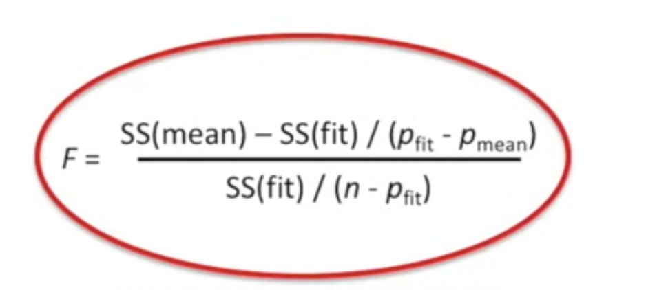erved values of y and taking the sum of these squares and dividing by the number of points
* Variance around fit is calculated by taking square of distance between the observed value and the fitted line and summing the squares and dividing by the number of observations
* A large R-squared value means a good fit
* But to tell if the calculated R-squared is statistically significant, we calculate the p value which is calculated from the F distribution
* F is given by

Where rho_fit is number of paramters in fitted line and rho_mean means number of paramters in mean line

We first generate random points and caluclate the f values we do this a large number of times and create a histogram of the f values obtained

The p value is the number of more extreme values divided by the total number of values.

The p values are smaller when there are more samplesrelative to the number of paramters in the fit.

We want this p value to be small.

In linear regression , we want to know whether an independent variable contributes to the dependent variable or not, so our null hypothesis is beta_1(coefficient of independent variable we need to check) = 0 and we got beta_1 to be 250 from fitting the best line, p value is defined as if our null hypothesis is true, how probable is the event that the parameter takes extremes value,

* If we calculate the p value using the values , we get p value as 0.002 which means there is 0.2 percent chance that we get extreme value , thus we can reject null hypothesis

Multiple linear regression

* The formula for calculating the R-squared values and p values for multiple regression is same as that of simple linear regression.
* The main thing about the multiple linear regression is that we can compare it with simple linear regression to tell whether the addition variable was worth taking or not.
* The formulas for calculating the R-square and p value are similiar, where the only difference is that instead of mean line we have simple linear regressed line and in place of simple linear regressed line we have multiple regressed line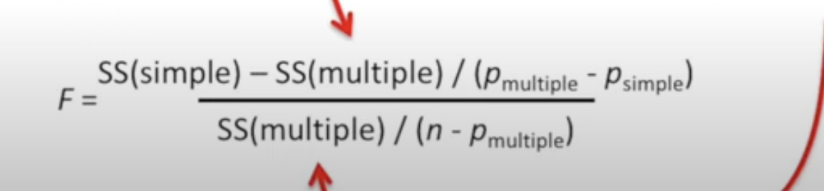
* If the r squared value is large and p value is small then it is benefeicial to consider the additional variable

t-Test and ANOVA

* t-Test is used for testing whether two means of two populations are same or not, this done by calculating the p values similiar to how we calculated for the linear regression
* Suppose we are given data of gene expression of mice with control gene and mice with mutant gene.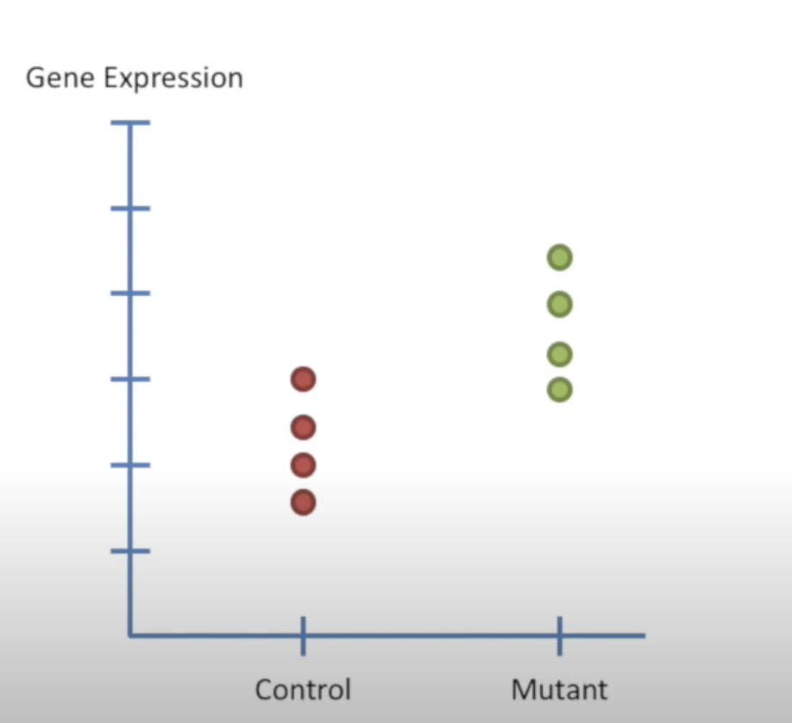
* First we calculate the overall mean and sum of square of residuals around mean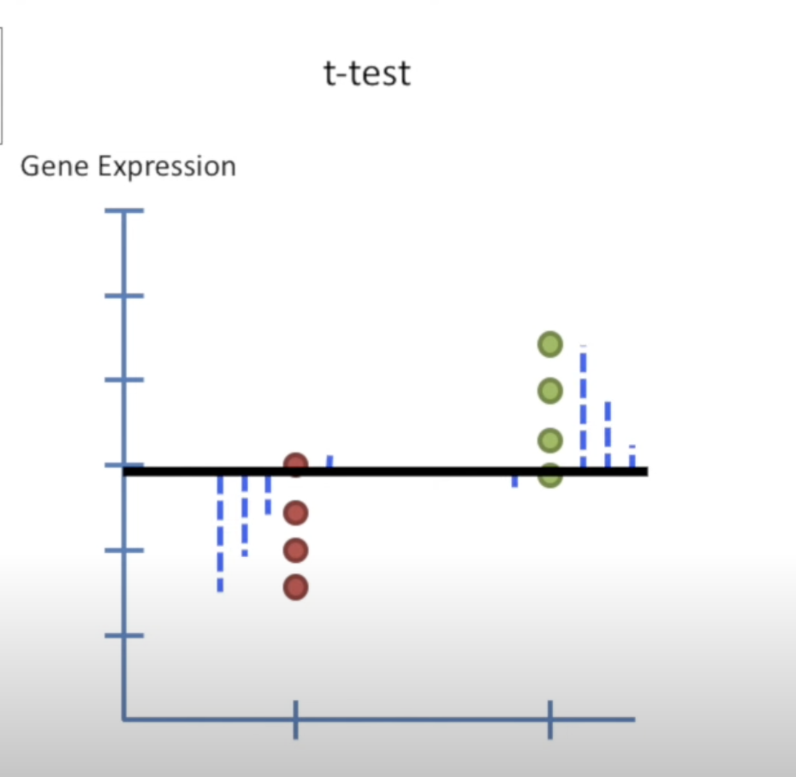
* Now we want to fit a line to the data, the least squared fit is the mean of control mice and mean of mutant mice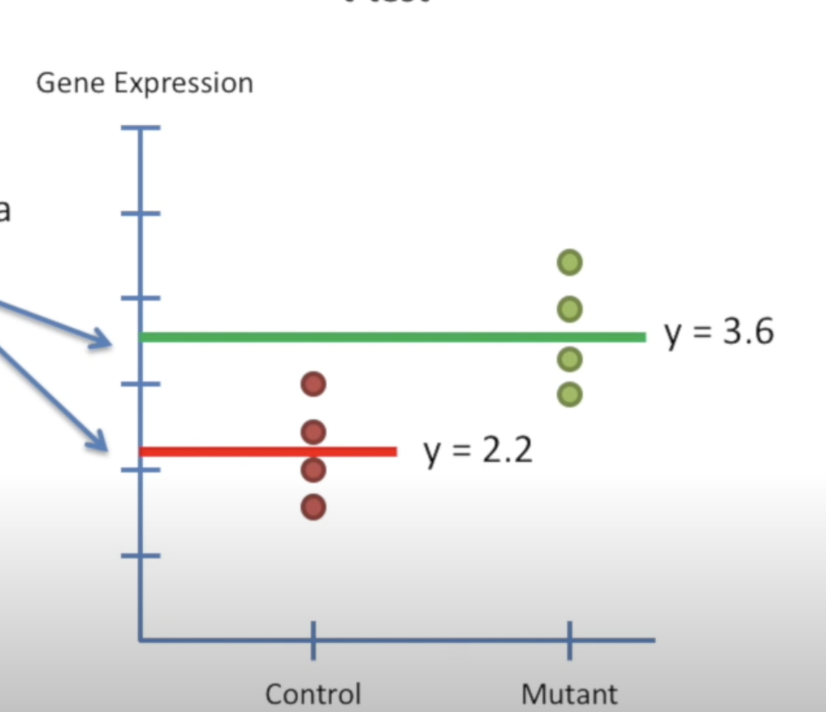
* Now we want to combine the two lines, for a point of control mice we can write it as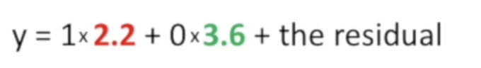

The residual is the distance of point from the least squared fitted line which the mean of control mice, similiarly we can write the equation of each point and we get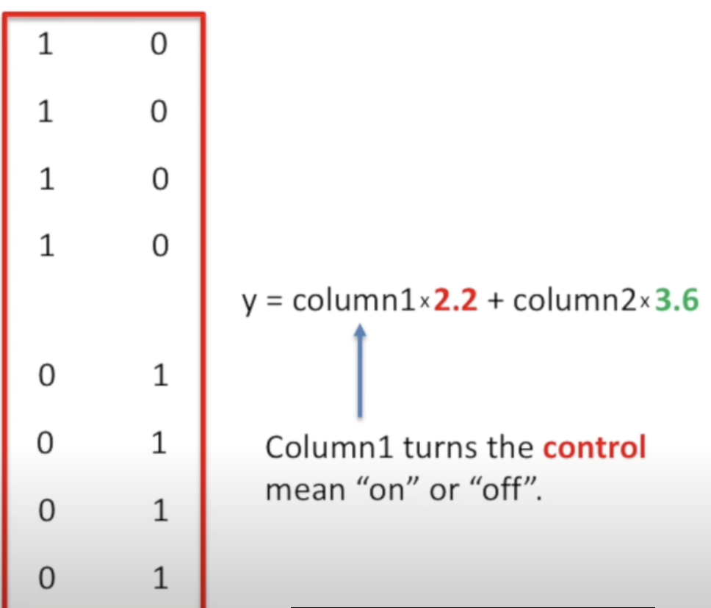

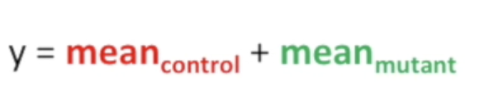

* The matrix is called design matrix
* Now we can use the formula for F used in linear regression to calculate F value in above case, here rho_fit = 2 (mean_control and mean_mutant). Thats how we calculate the F value for t test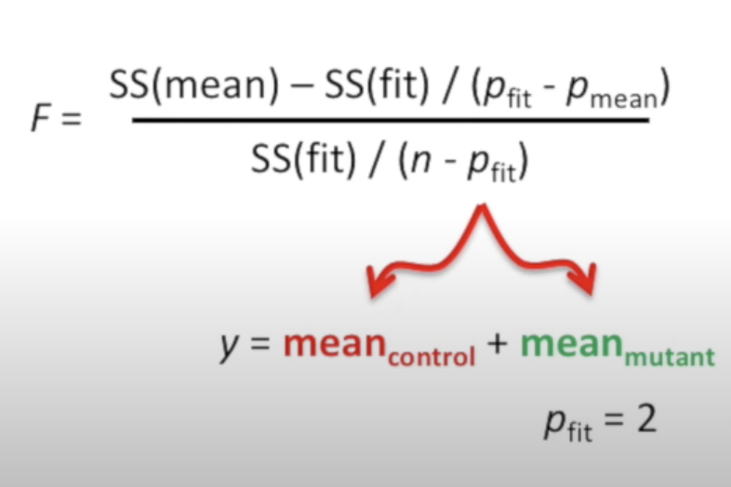
* ANOVA tests if all the categories are the same for eg .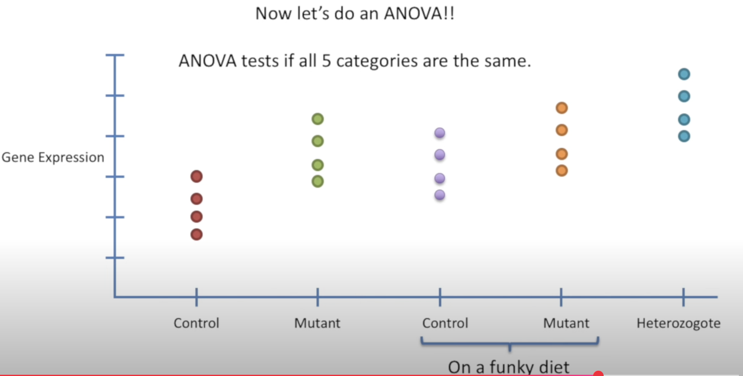

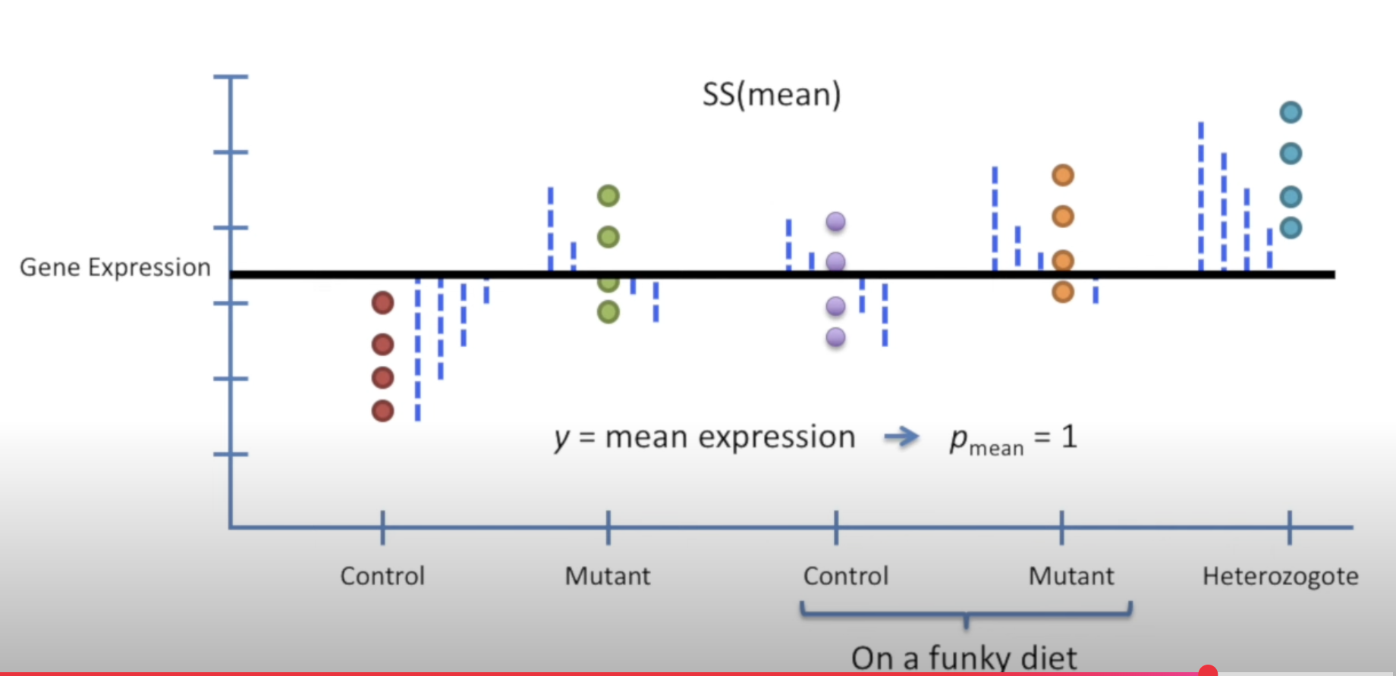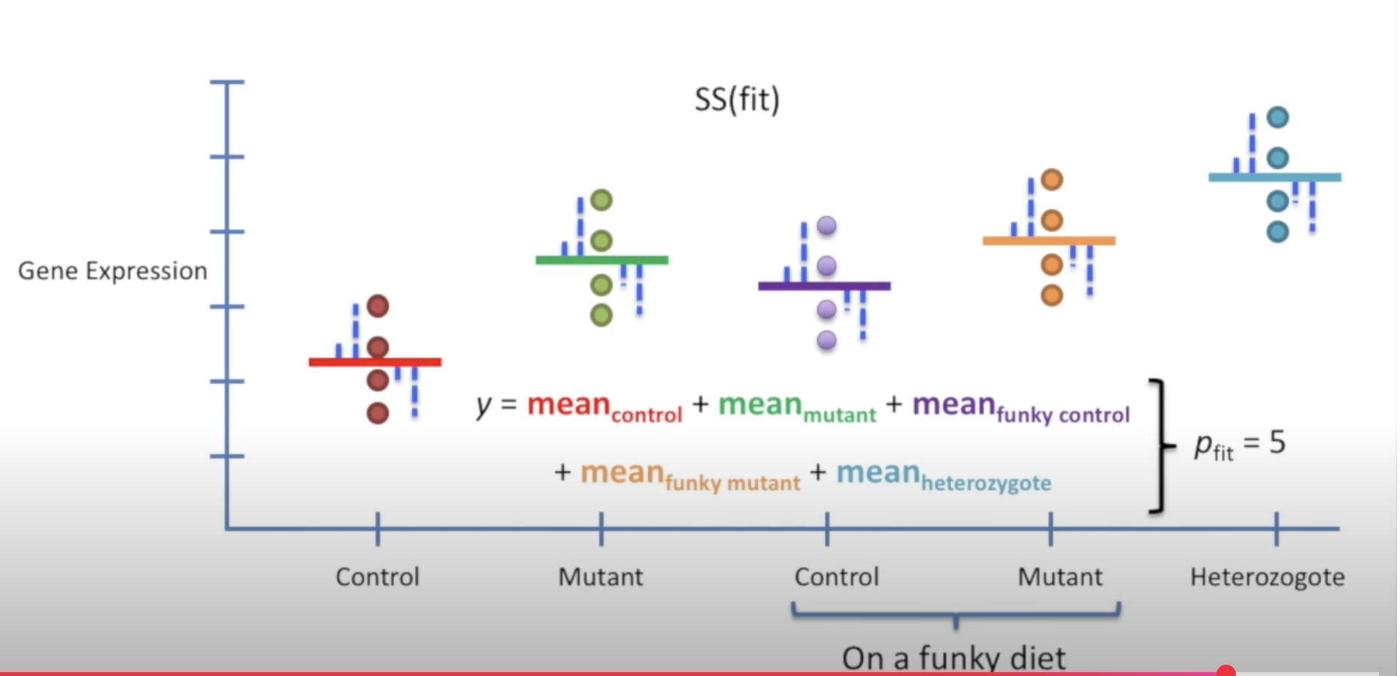

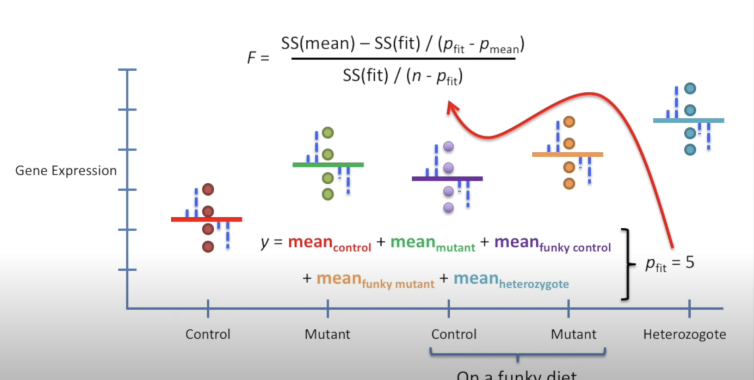

More about design matrices

* Design matrices above are not commonly used , the ones commonly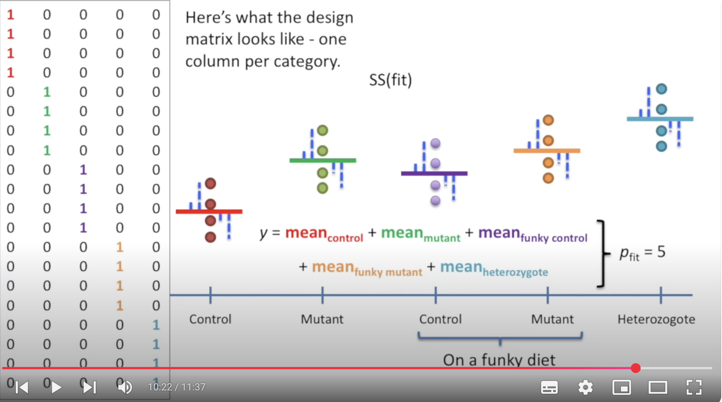 used are as follows
* It takes into account the offset between mutant mean and control mean
* Now we combine t-test and linear regres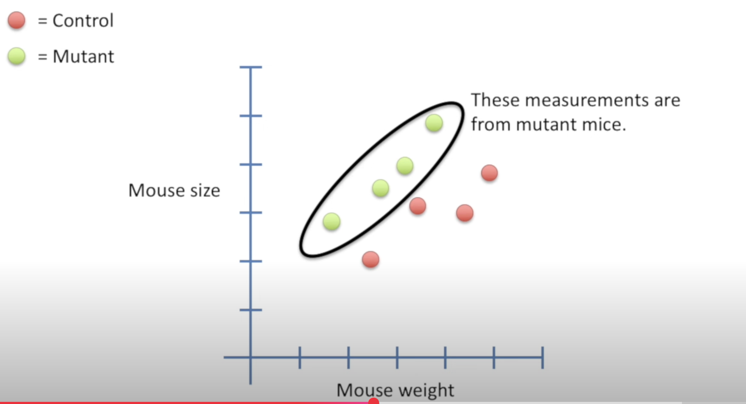sion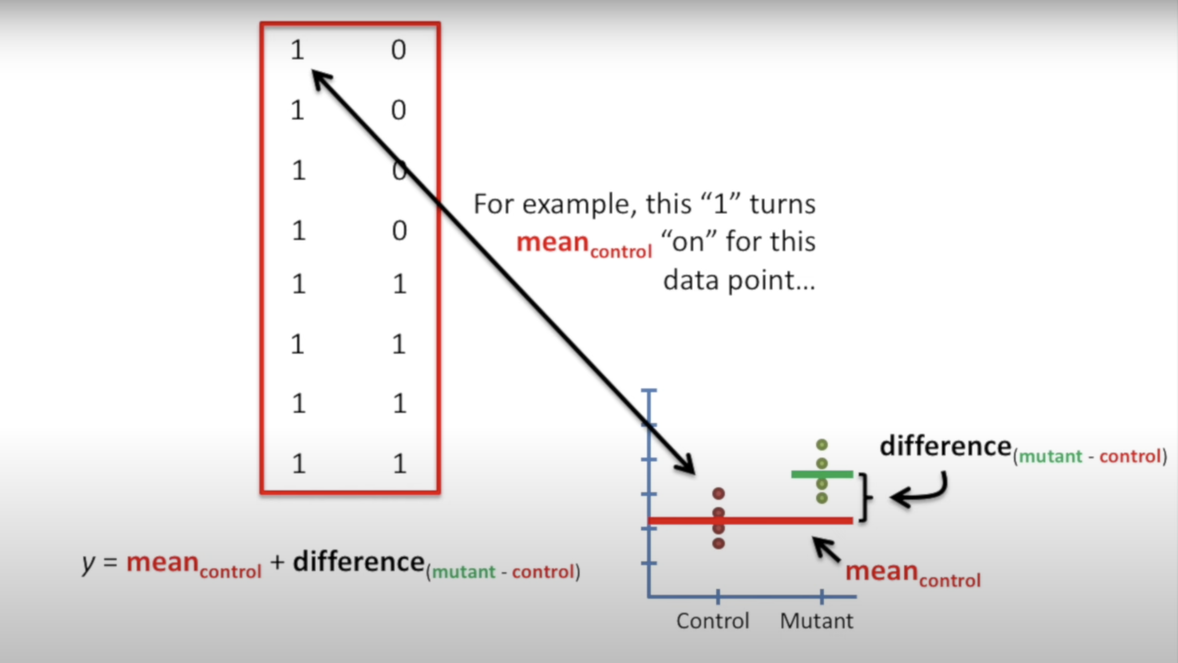
* We want to compare the two lines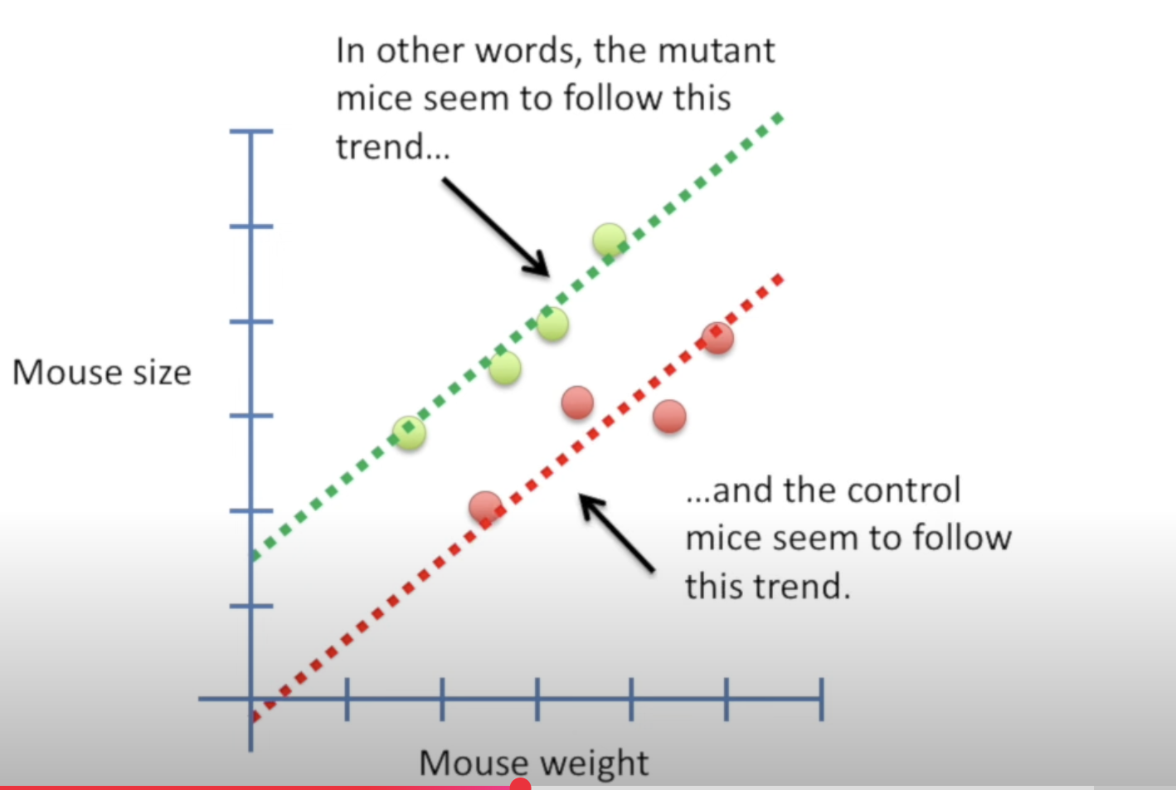
* Rho_fancy would be 3 since there are three paramters (control intercept, mutant offset and slope)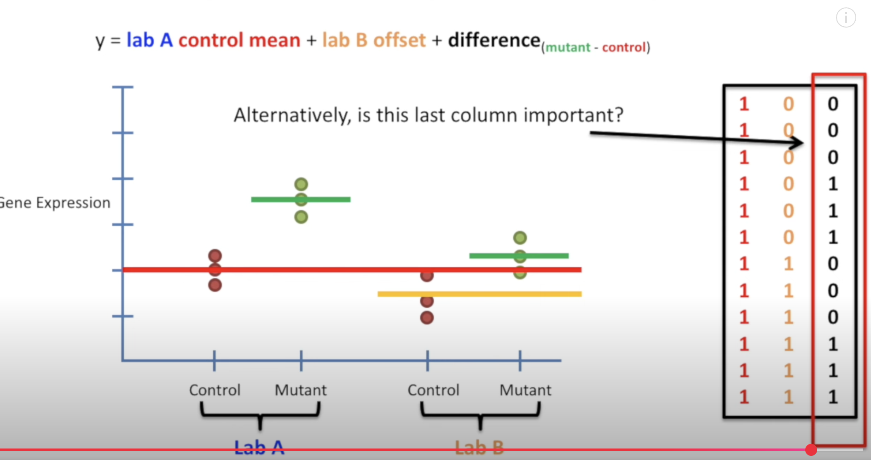

Odds and log of Odds

* Odds refer to ratio of something happening to something not happening
* For eg, “Odds of my team winning is in favour 6 to 1” means odds are 6/1 = 6
* To make things symmetrical , we generally calculate log of odds
* One can also find odds from probability which is log(p/(1-p)) where p is the probability of something happening
* The log of odds is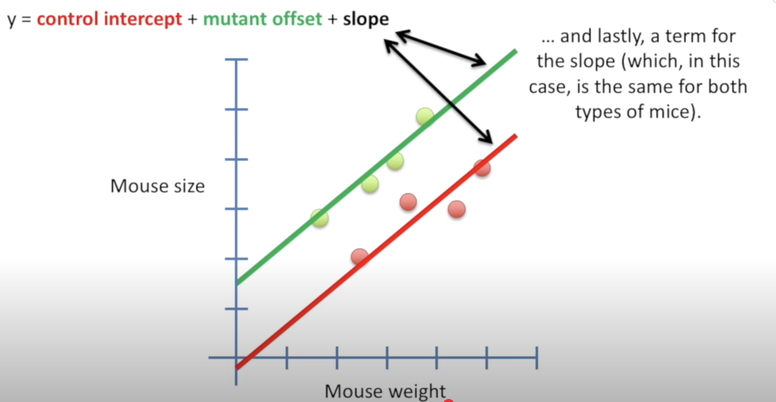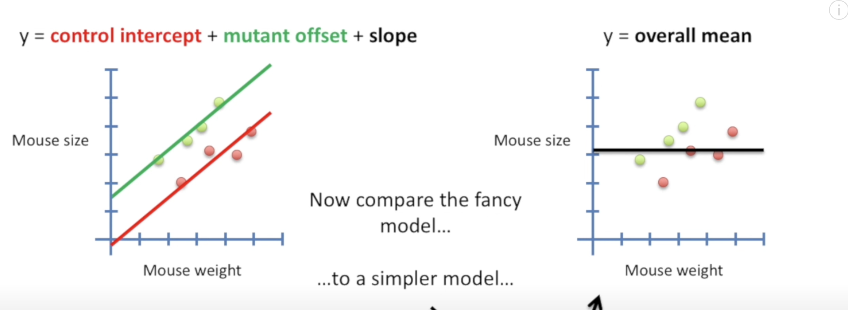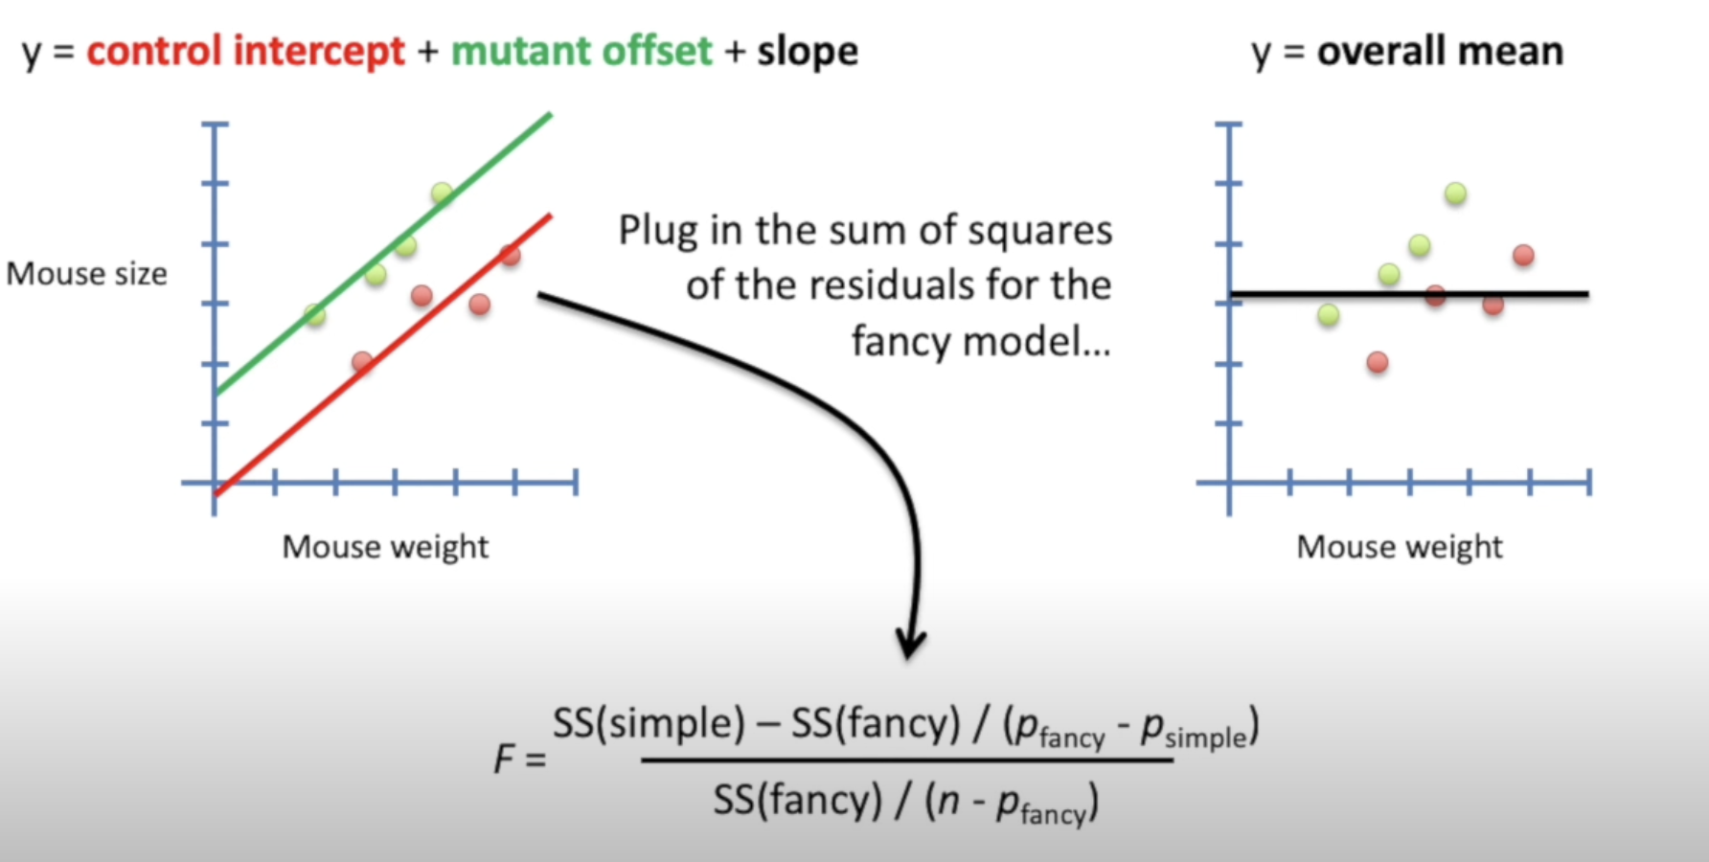 also called logits and is used in logistic regression

Odds ratio and log of odds ratio

* Odds ratio is basically ratio of two odds
* For eg, we want to know whether having mutated gene results in higher chance of having cancer, so we calculate odds ratio which is 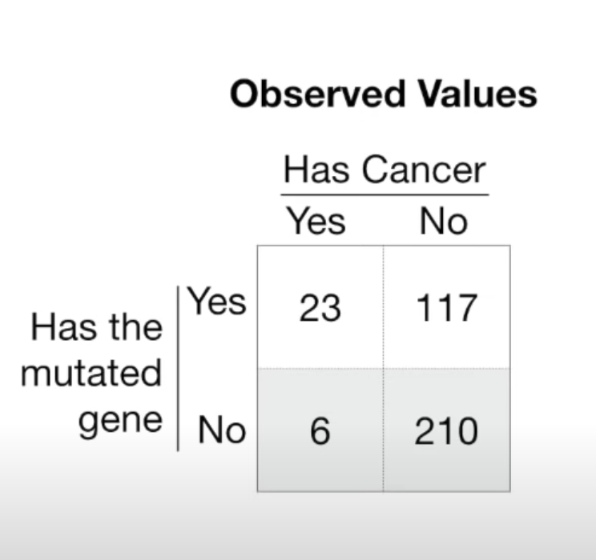

In numerator, given mutated genes , odds of getting cancer = 23/117 = 0.196

In denominator, odds of getting cancer without having the mutated gene = 6/210 = 0.02857

Therefore the odds ratio is 6.8803

* We can see odds ratio as a similiar prameter like R-squared value.
* Next we want to check if it is statistically significant which is done by calculating the p value.
* There are three methods to calculate the p value which are
  + Fischer exact test
  + Chi- squared test
  + Wald test
* Wald test is different from the other two in the way that it calculates the p value and also gives the confidence interval.
* For more refer to the video below[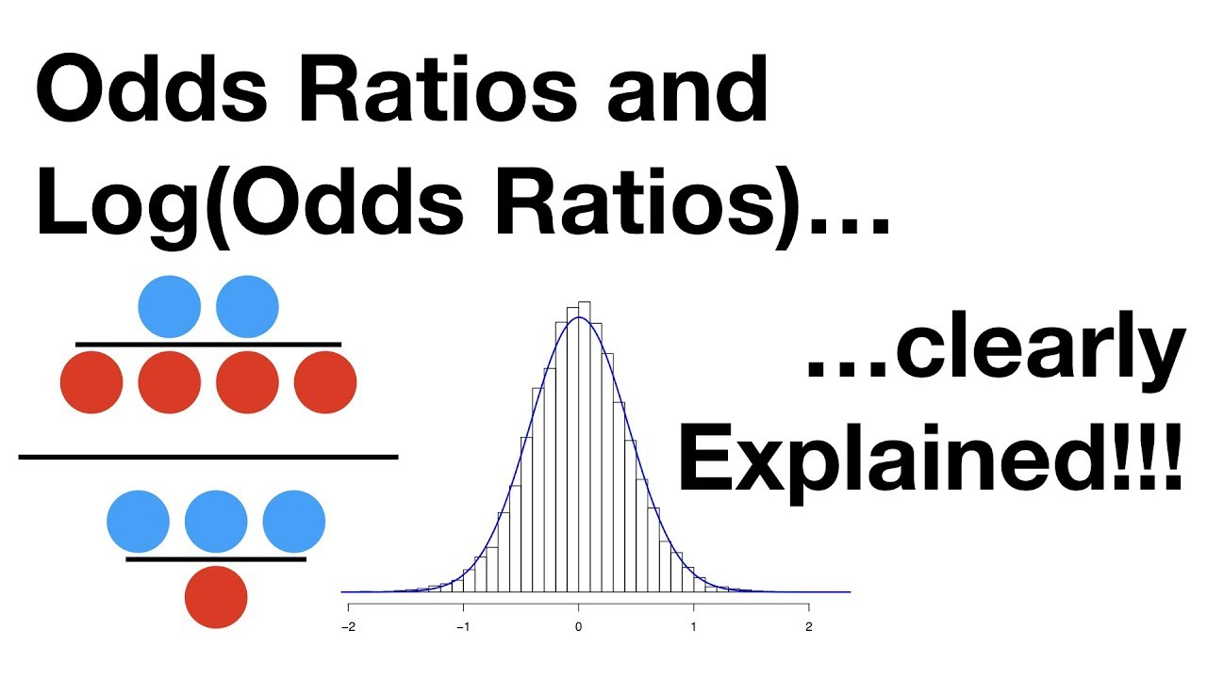](https://www.youtube.com/watch?v=8nm0G-1uJzA)